# Exercise Set#4 - Pipe, redirection and services (exercise related to FTP/TFTP, NFS, Samba, Telnet, etc.)

**Redirections, Pipes, services & Advance file-system mounting**

The Objective is to learn basic redirection symbol and usage of pipe to redirect standard output of one command to standard in of other command.

**Videos :** Linux4-ssh_scp, Linux4-minicom_serial

**1. Redirection**

**a. Use ls –l command to redirect the standard output, using “ ’>’, ‘>>’ ” symbols**

**Ans :**

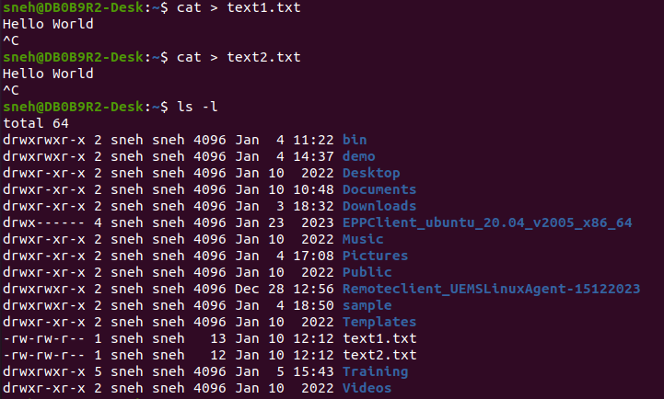

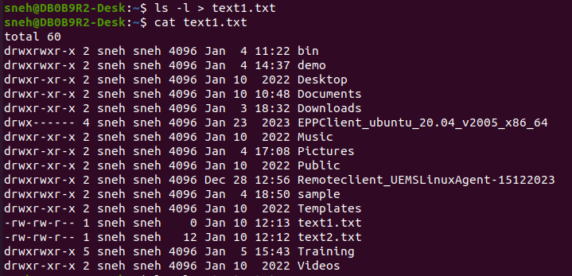

‘>’ will overwrite the content.

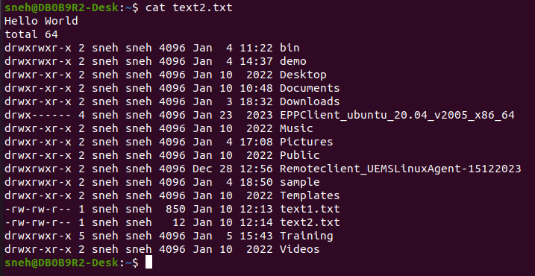

‘>>’ will append the content.

**b. Difference between ‘>’ and ‘>>’**

**Ans :**

‘>’ and ‘>>’ are both used for redirecting output.

‘>’ is used to redirect standard output and will overwrite the output.

‘>>’ is used to redirect and append standard output.

**c. Use the <tee> command to send the standard output to t he screen and to a file simultaneously.**

**Ans :**

Tee command allows you to redirect the standard output to both the screen and a file simultaneously

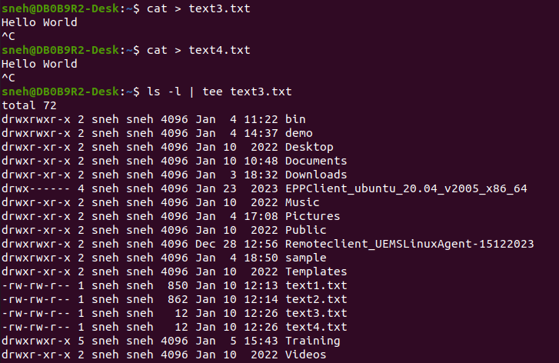

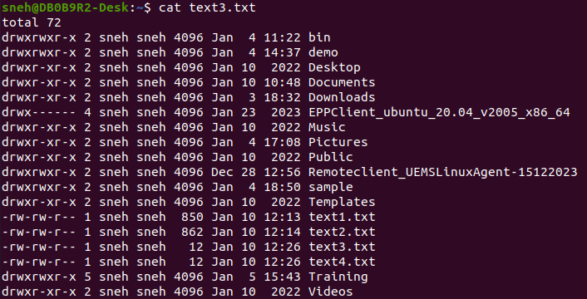

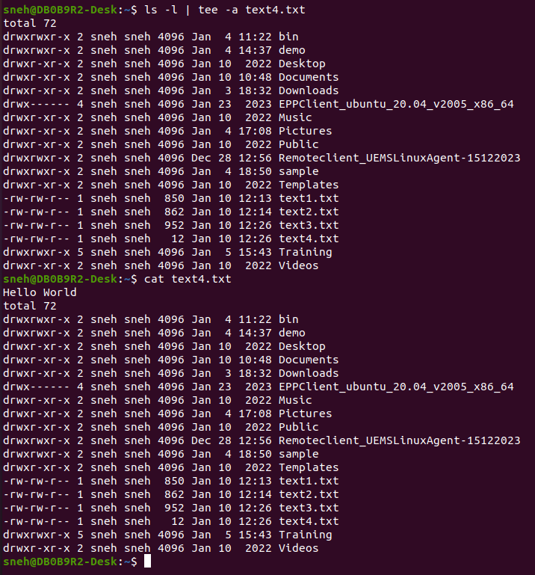

**d. Can we have redirection in form of ‘<’? If yes give some example**

**Ans :**

Yes, the < symbol is used for input redirection in Linux. It is used to take input from a file and provide it as input to a command.

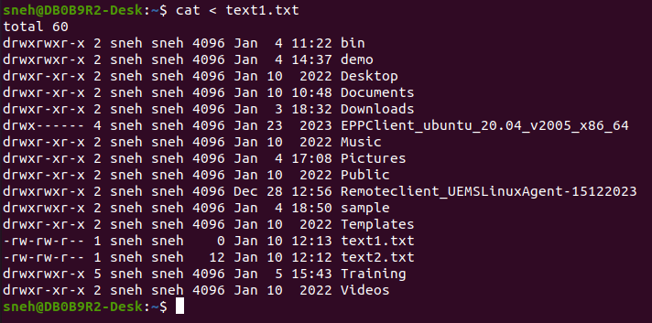

**2. Pipes**

**a. Use combination of two commands to learn how “|” symbol can be used.**

**Ans :**

Pipes in Linux are used to connect the output of one command to the input of another.

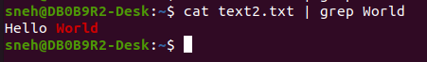

**b. <more> and <less> command.**

**Ans :**

The **more** command is used to display the contents of a text file one screen at a time. It's often used when viewing longer files.

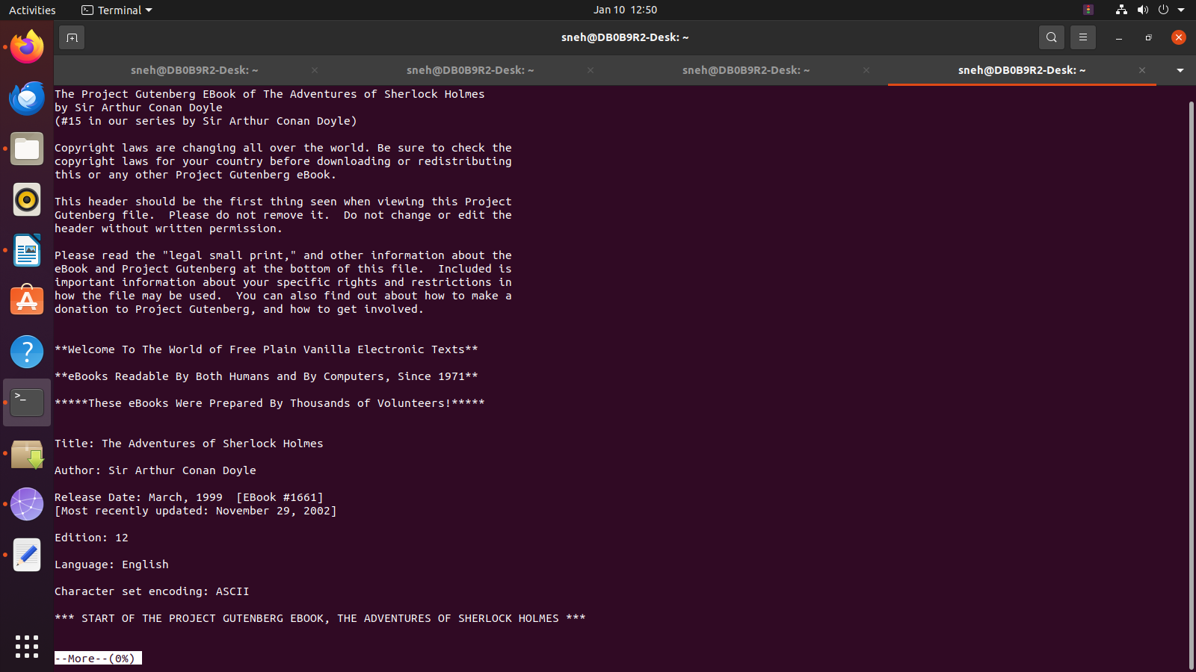

The **less** command is similar to more but provides additional features like scrolling backward and forward. It's a more versatile pager for viewing text files.

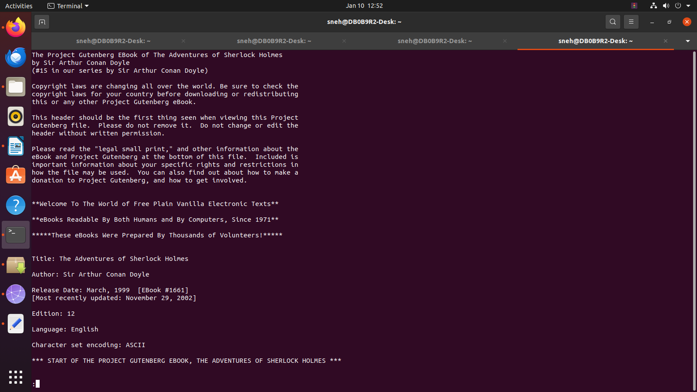

**c. <head> and <tail> command.**

**Ans :**

The head command displays the first few lines. The tail command shows the last few lines. By Default 10 lines are selected.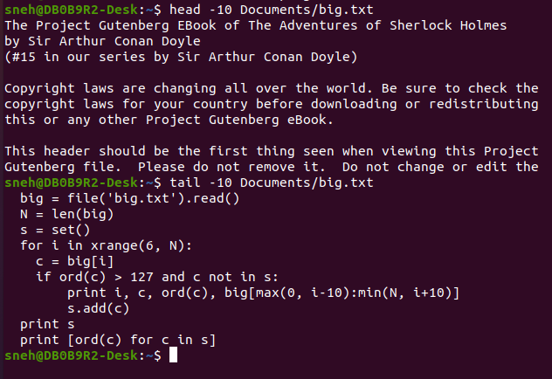

**3. Services**

**a. What are services and various services?**

**Ans :**

Service is a program or application that run in background and provide us specific resources to other program ,device or users.

Types of services:

Web service(Apache)

Network services (SSH,DHCP,DNS)

Database services (MySQL, MongoDB), etc.

**b. What are SSH, NFS, TFTP, SCP, TELNET and service?**

**Ans :**

* **SSH (Secure Shell):** It is a protocol that provides secure remote access to a system over a network. It allows users to log into another computer, execute commands in a remote machine, and move files from one machine to another securely.
* **NFS (Network File System):** It is a distributed file system protocol that allows a user on a client computer to access files over a network as if they were on the local machine. It enables sharing and accessing files among multiple systems in a network.
* **TFTP (Trivial File Transfer Protocol):** TFTP is a simple file transfer protocol used for transferring files between devices on a network. It lacks some of the features of a more robust protocol like FTP but is often used for basic file transfers, such as firmware updates for networking equipment.
* **SCP (Secure Copy):** It is a secure file transfer protocol that uses the SSH protocol for data transfer and provides authentication and encryption. SCP allows secure copying of files between a local and remote host or between two remote hosts.
* **Telnet:** Telnet is an older network protocol that provides a bidirectional text-oriented communication facility. It allows a user on one computer to log into another computer on the same network, provided they have the necessary permissions. However, Telnet is considered insecure as it transmits data, including passwords, in plaintext.

**c. After you are comfortable about the different services choose one service to experiment on it using the below instructions**

**Ans :**

I will use SSH for below instructions.

**d. Check if desired service is available in your system? If not install and configure that service for your system**

**Ans :**

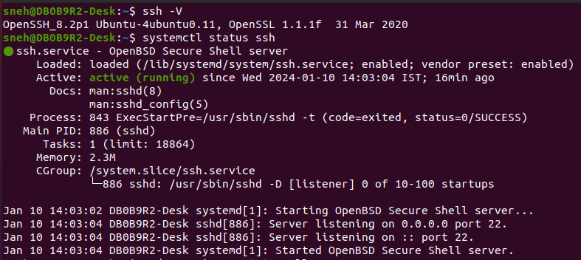

**e. Check the status of all the service with appropriate option to <service> command.**

**Ans :**

Each line represents a service, and the [ + ] or [ - ] indicates whether the service is running ([ + ]) or stopped ([ - ]).

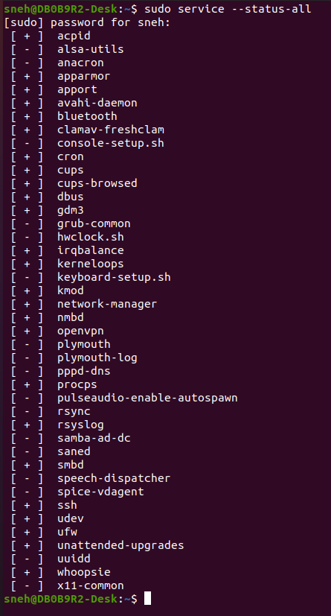

**f. Check the status of individual NFS service <service>**

**Ans :**

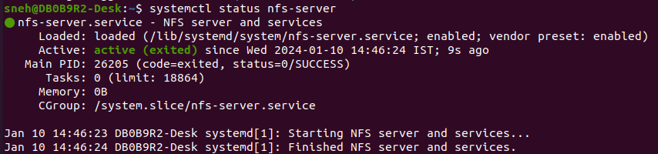

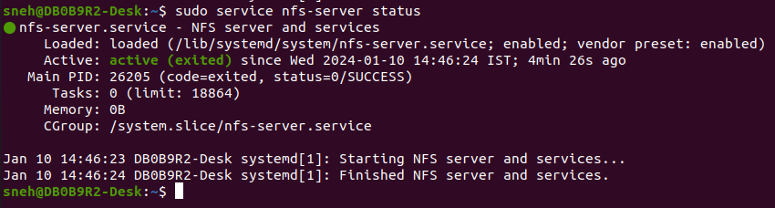

**g. Stop the NFS service if it is running <service>**

**Ans :**

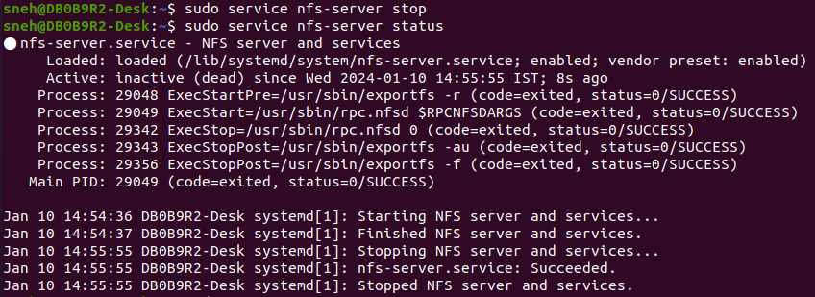

Same result can be achieved by systemctl command.

**h. Start the service again <service>**

**Ans :**

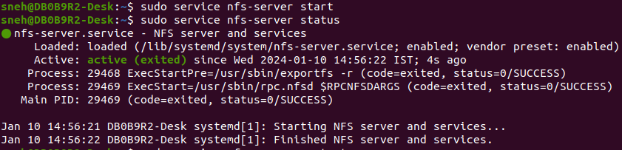

Same result can be achieved by systemctl command.

**i. Restart the service <service>**

**Ans :**

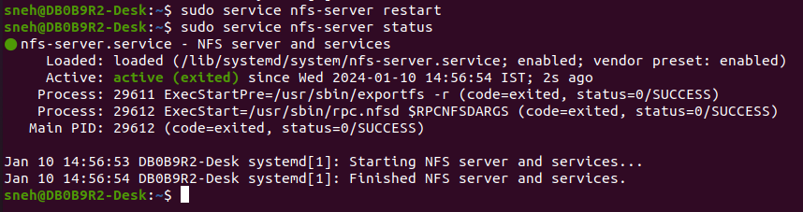

Same result can be achieved by systemctl command.

**j. Change the runlevel of a service. Learn how to permanently change the runlevel of a service**

**Ans :**

Runlevel is a mode or state in which a linux system operates. It decides state of machine after boot.

* Runlevel 0: Halt or shutdown the system.
* Runlevel 1: Single-user mode or maintenance mode.
* Runlevel 2: Multi-user mode without networking.
* Runlevel 3: Multi-user mode with networking but without a graphical user interface (GUI).
* Runlevel 4: User-definable/runlevel for custom purposes.
* Runlevel 5: Multi-user mode with networking and a graphical user interface (GUI).
* Runlevel 6: Reboot the system.

**k. What is “xinetd”? Identify one of the service which runs under xinetd**

**Ans :**

xinetd, short for eXtended InterNET Daemon, is a super-server daemon on Unix-like operating systems that coordinates the execution of network services. It listens for service requests on designated ports and launches the appropriate service as needed. Unlike traditional daemons, which are continuously running, xinetd is event-driven, meaning it starts a service only when there is a request for that service.

Some services that commonly run under xinetd include FTP, Telnet, POP3, IMAP, etc.

**l. What is SSH? Why is it required?**

**Ans :**

SSH is widely employed for accessing and managing remote systems securely. SSH provides a secure channel over an insecure network by using encryption to protect the transmitted data from eavesdropping or tampering.

Why it's Required:

* Security: Protects data and ensures secure access to remote systems.
* Remote Management: Essential for system administration and troubleshooting.
* File Transfer: Facilitates secure file transfers between systems.

**m. Learn how to login to remote machine via SSH**

**Ans :**

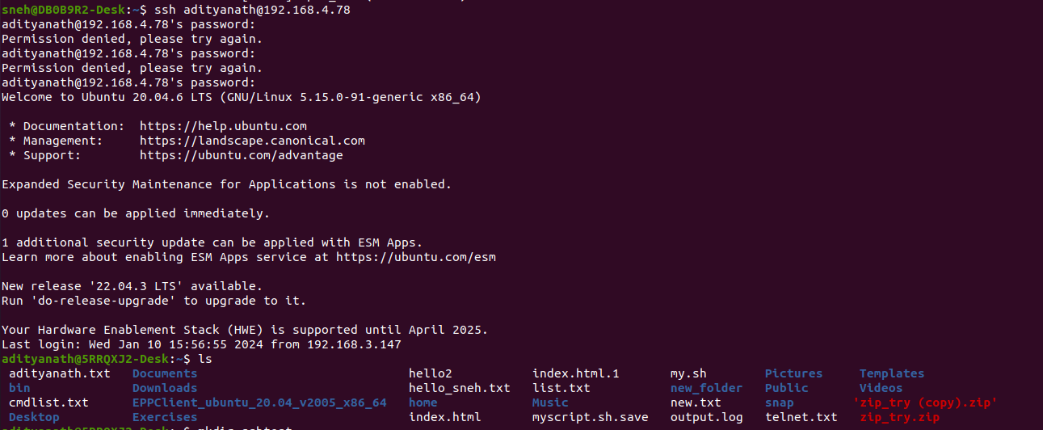

**n. Copy a directory from a remote machine to a local machine using ssh**

**Ans :**



**o. What is minicom? How it works?**

**Ans :**

Minicom is a communication tool that allows users to interact with devices connected to the serial ports of a computer. It is commonly used for configuring and troubleshooting devices like routers, switches, and other embedded systems that use serial communication.

**4. Advance file-system mounting**

***Samba***

**a. What is samba server and samba client?**

**Ans :**

In Linux, Samba is a suite of programs that enables seamless file and print services between systems running Windows and those using the SMB/CIFS protocol. The Samba server allows a Linux system to act as a file and print server for Windows clients. It facilitates sharing files, printers, and other resources across a network.

On the other hand, a Samba client is a system or software that can access resources shared by a Samba server. It allows Linux systems to connect to and interact with shared folders, printers, and other services provided by a Samba server, as if they were on a Windows network.

**b. Check if samba service is installed in your system, if not installed it**

**Ans :**

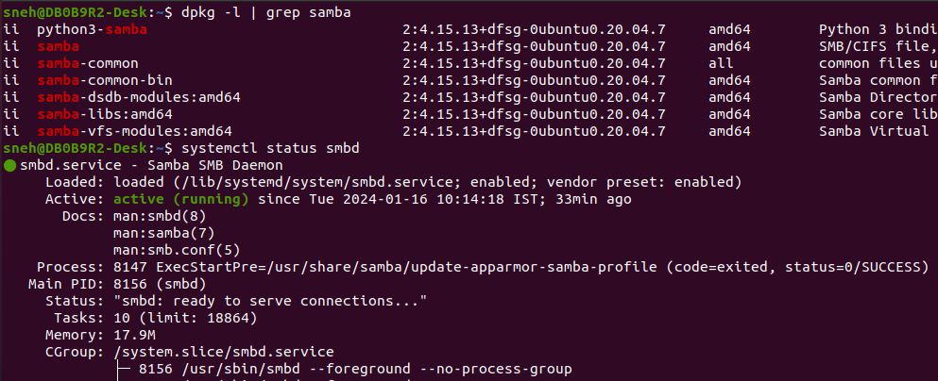

**c. Start the samba services if not started**

**Ans :**

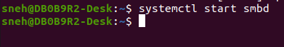

**d. List the contents of a Remote Windows machine shared folder on your Local Linux command prompt using <smbclient>**

**Ans :**

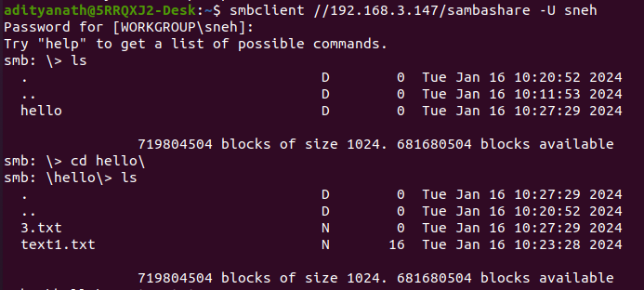

**e. Connect to the Remote Windows machine shared folder <smbclient> and <get> and <put> file to and fro.**

**Ans :**

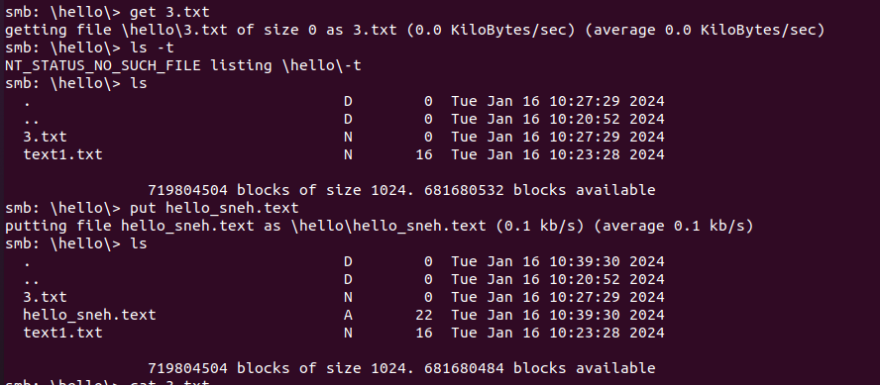

**f. Mount a Remote Windows machine shared folder on to your local Linux Machine using samba file system mount <mount>**

**Ans :**

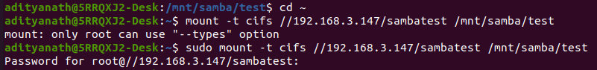

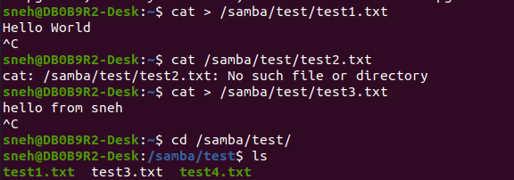

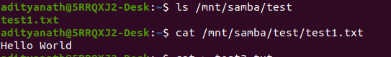

***NFS***

**g. Check if NFS service is installed on your system? If not installed and configure NFS for your system**

**Ans :**

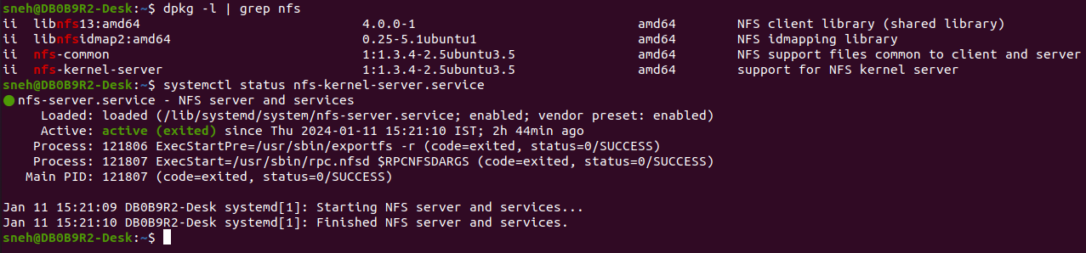

**h. Start the NFS service if not started**

**Ans :**

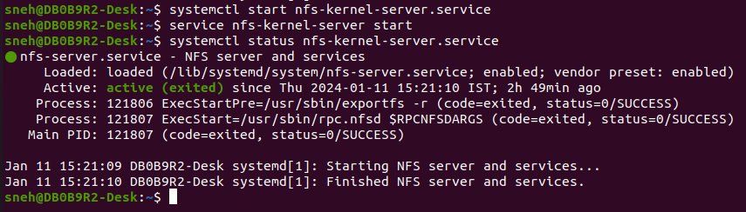

**i. Make one directory in local remote machine**

**Ans :**



**j. Via NFS mount make this remote directory shared between remote machine and your machine.**

**Ans :**



